Writing in the EYFS | - As soon as children know some sounds, story scribing with helicopter stories is introduced (children write the learnt initial sounds independently). Writing is child-initiated. | - All pots and equipment are labelled with phrases/sentences.
- Writing evidence is recorded to show each child’s journey (adult and child-initiated tasks). | - Provision activities include a writing element, e.g. one example was a sign for ambulance that was constructed in the outdoor area, writing was prompted by adults, e.g. Who’s inside? Why? Everything ‘made’ needs a label, sign or description – writing is everywhere! | - Daily morning activity in place for all children – for example, children respond to an image/artefact etc by writing a caption, or similar, for it.
- A wide range of genres covered, e.g. recipe, letters, lists, invites, signs, posters, cards - writing for a purpose is encouraged. | - Weekly sticker challenge for independent writing linked to the theme. | - Children develop their fine motor skills and letter formation through the ‘ Squiggle Whilst you Wiggle’ and ‘Squiggle me into a Writer’ programme.
- Reading and writing on bananas (fruit basket) linked to RWInc sounds. | - Set 1 and 2 phonics sound mats and red words available in all areas for children to refer to when writing in continuous provision. | 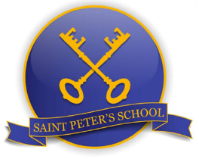
N.B. During a Helicopter Stories session, children dictate their stories to an adult scribe. Members of the class then gather and the stories are acted out. This is a form of child-centred learning, as the pupil is in control with the freedom to create in any way they want and bring their individual story to life. In Helicopter Stories, children’s words are respected and the approach lends itself to collaborative play and sharing ideas. Helicopter Stories not only reinforces the connection between spoken and written words, but also gives pupils the chance to see how ingenious mark making and letters can be, which can in turn inspire them to explore writing in their own way. The approach has been shown to boost confidence in literacy and improve vocabulary skills, which enhances communication through speaking and listening.
September 2023

