Reading in the EYFS | - STAR time - daily storytime session. | - From week 3, phonics is taught whole-class - 1 sound per day.  After week 6, assessments take place, before differentiated groups.
- Author of the Term | - Phonics daily catch-up. Focus: CVC words, blending and revising initial sounds (for some). | - Children read picture books and those with single letter correspondences. When children can blend, they read books with words.
- All children are heard reading on a 1:1 weekly basis.  PPG, catch-up, SEND children listened to daily/more frequently  N.B. Books are chosen carefully and closely match learnt sounds, e.g. if children could read satpin they won’t be given a cvc book that has words with jvwz for example. | - Regular story-time sessions .  Children and families invited. | - Children have access to a range of thematic stories each day to provide the children with ideas to base their stories/writing on.
- EYFS section of whole-school questioning document used to develop high standards in early comprehension. | - High-quality text (weekly) in continuous provision for reading and writing activities. Provision is enhanced by resources which encourage retelling and acting of the story of the week. | 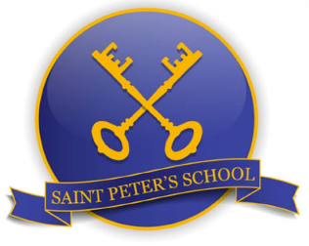

September 2023

