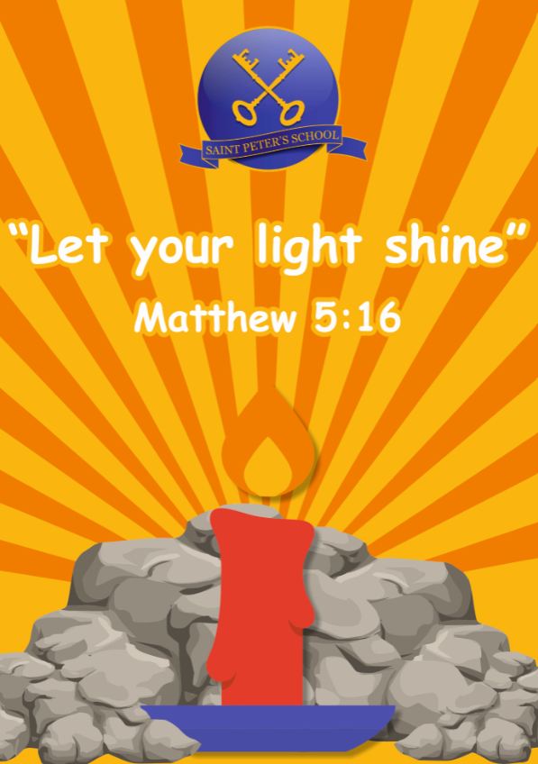

RE POLICY

Date: April 2023
Review : April 2027



Barton St Peter’s C of E Primary School
Religious Education and Worldviews Policy

Barton St. Peter’s Church of England Primary School aims to work within the Diocesan Vision to teach RE through excellence, exploration and encouragement. The purpose of RE is to develop pupils’ religious literacy, in order to be able to hold balanced and well-informed conversations. Religious Education enables children to investigate and reflect on some of the most fundamental big questions in life.

At Barton St. Peter’s School we develop the children’s knowledge and understanding of Christianity as the principal religion of the United Kingdom, as well as the major world faiths of Islam and Hinduism with Judaism as an additional faith. Non-religious beliefs such as Humanism are also key and intertwined.
These are taught through the disciplines of Theology, Sociology and Psychology or Believing, Living, Thinking and are carefully woven to deliver a curriculum that is progressive and robust.

We celebrate the variety of religious and non-religious backgrounds that make up our school community and we respect this variety of backgrounds in the spirit of Christian welcome.

We are fortunate to have good relationships with faith practitioners from a range of world faiths and we value their contribution to our provision of immersive and engaging RE.

We also believe that Religious Education has an important part to play in promoting the spiritual, moral, social, cultural and intellectual development of our pupils, the promotion of citizenship and development of personal, social and health education and key skills.

Furthermore, we actively seek to prepare our pupils for life in modern Britain. As such, we promote key British values, including respect for and tolerance of different faiths and beliefs. We challenge racism and all forms of prejudice and we see RE as a curriculum area in which our pupils can safely encounter, research and critically reflect on a range of worldviews.

In line with our vision “Let your light shine” Matthew 5:16, we understand the contribution of effective RE on our journey towards realising our school’s distinctively Christian vision through the lens of building community, hope, wisdom and dignity as children grow to understand the key tenets of central faiths within modern Britain.
As we state that Peter is our rock upon which children build their firm foundation, so too can RE be the rock upon which our children can grow as knowledgeable, spiritual and tolerant citizens in whatever form as they move on from a life beyond our local community.

Statutory Requirements
Every state-funded school in England must provide the Basic Curriculum which includes provision for RE for all registered pupils at the school (including all Reception pupils), except for those withdrawn by their parents in accordance with Schedule 19 to the School Standards and Framework Act 1998.

- The content of RE must reflect the fact that the religious traditions of Great Britain are, in the main, Christian; it must also reflect the teaching and practices of the other principal religious traditions represented in Great Britain
- The RE curriculum provided will be compliant with the locally agreed syllabus for North Lincolnshire which has adopted the Lincolnshire Syllabus and was formally agreed by all relevant parties in May 2019.
- We deliver RE in accordance with the Church of England Education Office’s Statement of Entitlement.
- It is the expectation of the Church of England Education Office that RE should constitute a minimum of 5% curriculum time. We meet this expectation by providing the minimum time of 36 hours per year for KS1 and 45 hours per year for KS2/KS3. This time is arranged in a variety of ways that best suit the topic and class so this could be as discrete hour-long lessons/RE days or a week.
- RE forms part of the planning at EYFS; although there is no expected time allocation at this level, we expect that there will be connections made between RE and the Early Learning Goals.
RE curriculum time does not include values lessons or collective worship.

Governing bodies and Headteacher’s must:
- Ensure that RE is provided as part of the school’s Basic Curriculum, following the locally agreed syllabus, unless they are schools who are free to choose the syllabus they follow (as above)
- Ensure that their RE curriculum is made available on the school’s website alongside other curriculum subjects
- Have an accessible route through which parents and others can request information about RE; schools may seek advice from their SACREs in addressing issues concerning RE provide an annual report to parents or carers giving brief particulars of progress and achievements in all subjects including RE
- Provide sufficient time for the school to fulfill the requirements of the locally agreed syllabus.

The Curriculum
Our programme of study is compliant with the requirements of our local SACRE, which is delivered through a carefully constructed 2 year curriculum cycle, purposely designed for our local community.

This takes its main structure and resources from the Lincolnshire Syllabus and its unit resources, blended with units from the Understanding Christianity resource as well as additional units which reflect our local community.

Our curriculum weaves the key disciplines of Believing, Living, Thinking in order to ensure academic rigour as a core subject and enable year on year progression.

At KS1, the principal religions studied will be Christianity and Islam with a specific unit on Judaism as part of our community links.
At KS2, the principal religions studied will be Christianity, Islam, Hinduism with again, links to Judaism. It is expected that pupils will also encounter non-religious worldviews, such as Humanism as part of their RE curriculum.

Within this framework our aims in RE are for pupils to:
- Acquire and develop knowledge and understanding of Christianity and a range of world faiths and worldviews;
- Develop an understanding of the ways in which religious and non-religious beliefs, teachings, practices, values and traditions influence individuals, communities, societies and cultures, from the local to the global contexts;
- Develop the ability to make reasoned and informed judgements about religious and moral issues, with reference to the beliefs, teachings, practices, sources of authority and ways of living associated with the principle religions represented in the UK;
- Develop positive attitudes of mutual respect for and tolerance of those with different faiths and beliefs;
- Enhance their spiritual, moral, social and cultural development by:
  - Considering the ‘big questions’ raised by human experience and reflecting on how religious and other traditions respond to them;
  - Responding to such questions with reference to religious beliefs, teachings, practices, values and traditions, relating them to their own understanding and experience;
  - Reflecting on their own beliefs, values and experiences in light of their study of religious and other traditions.

Teaching and learning style
The Statement of Entitlement advocates rigorous enquiry, analysis, interpretation, evaluation and reflection which we subscribe to wholeheartedly and seek to deliver.
Our teaching and learning styles in Religious Education enables children to build on their own experiences and extend their knowledge and understanding of key religious concepts by becoming co-researchers and being immersed in the richness of the subject through artefacts, texts, music, art, experiences and visits etc in order to develop their own worldview.
We also promote and are at the forefront of developing our unique of ‘maps’ or ‘knowledge organiser’ in order to deliver a more cohesive curriculum and learning that children can ‘link up’ via dual coding eg visuals and key vocabulary.

We have strong links with our local churches and excellent multi-faith relationships with the local Muslim and Jewish community, as well as our new Hindu friends which we consider key to delivering a high quality curriculum.

Our teaching encourages children to explore and challenge their own sense of values and promotes their spiritual growth and development as we provide opportunities for children to think about these in relation to the big questions.

We recognise the fact that all classes in our school have children of widely differing abilities, and so we provide suitable learning opportunities for all children by matching the challenge of the task to the ability of the child whilst never setting a ceiling – all children can achieve high.

We do this in a variety of ways:
- Setting common tasks which are open-ended and can have a variety of responses.
- Setting tasks of increasing difficulty (we do not expect all children to complete all tasks).
- Grouping the children by ability in the room and setting different tasks for each group.
- Providing resources of different complexity, adapted to the ability of the child.
- Using classroom assistants to support the work of individuals or groups of children Encouraging children to work creatively, allowing for all pupils to succeed.

In terms of CPD, we invest heavily and regularly in all the latest and appropriate training and resources for all staff based on their requirements and this can be seen on detailed termly trackers from the RE Lead which monitor effectiveness..

Curriculum Planning
Religious Education is taught in all year groups. It is planned for at Long, Medium and Short Term levels. All staff plan from the Programmes of Study in the Agreed Syllabus using a range of materials to support this. We offer opportunities for children of all abilities to develop their skills and knowledge in each unit. We ensure that the planned progression built into the scheme of work offers the children an increasing challenge as they move through the school.

The Long Term plan maps the Religious Education themes studied in each term during each Key Stage over the whole year. Medium Term plans give details of each unit of work for each term. These are taken straight from the Agreed Scheme of Work from the Agreed Syllabus and Understanding Christianity. These are provided by the school. Short Term plans consist of specific learning objectives for that lesson and the activity used to deliver that objective along with appropriate assessment arrangements. Short term planning is the responsibility of the teacher.
These are discussed on an informal basis with the RE Subject Leader and form part of the annual monitoring process for RE teaching and learning.

Assessment, Recording and Reporting
This is through on-going Teacher Assessment on a weekly basis through success criteria and twice-yearly knowledge checks. Evidence is gathered through observation, oral discussion, written tasks and class trackers which monitor pupil progress over the terms and across the disciplines.
The pupils’ overall attainment is reported annually through the written report at the end of the year. Samples of children’s work are kept in floor books showing the progression and depth of understanding as well as regular ‘book looks’ by the RE Lead.

Cross curricular links
RE contributes significantly to the teaching of English by actively promoting the skills of speaking and listening, reading and writing. The texts used from Understanding Christianity have religious themes or content, which encourage discussion and this is one of the ways in which we promote the skills of speaking and listening, as well as to write creatively in order to develop their writing ability.
There are also very strong links with music, art and design, and drama. These links are planned for at the short term level where appropriate.

Withdrawal from RE
We acknowledge the right of parents/guardians to withdraw their children from RE lessons and of teachers to withdraw from teaching the subject. We acknowledge that parents/guardians/teachers do not need to provide a reason why they wish to withdraw from the subject. Should a parent/guardian wish to withdraw their child from RE lessons or a teacher wish to refuse to teach RE, we ask that the head teacher is informed as soon as possible. We encourage parents to discuss their thoughts with the head teacher.

The use of Language
Children are given the opportunity to develop the skills to express themselves correctly and appropriately, listen to others and read with understanding special religious texts matched to their level of attainment. This includes key vocabulary for each key religion and is supported by our ‘key words ticklist’ at the start of each unit and referred to throughout in order to embed religious literacy.
We actively promote the use of positive language when looking at the diversity of faith, culture, experience and belief. Any incident of racism is reported, as required, according to both the school and LA policy.

S.E.N. and Differentiation
In our school we teach Religious Education to all children, whatever their ability. The teaching of Religious Education is a vital part of our school curriculum policy, which states that we provide a broad and balanced education for all our children. The content of the Religious Education curriculum is the entitlement of every child. When teaching Religious Education we ensure that we provide learning opportunities matched to the needs of children with learning difficulties. Differentiation is identified and planned for at short term level and any additional support for the individual is noted.

Gifted and Talented
It is our responsibility to ensure that all children are challenged and their abilities nurtured. Challenge can be provided in a variety of ways, such as, varying the complexity of the subject matter or depth and complexity of questions, or changing the teaching and learning style.

Inclusion
In planning and teaching Religious Education we have due regard for the following principles:- ∙ The setting of suitable learning challenges. ∙ The response to children’s diverse learning styles.

Equal Opportunities
All staff will try to ensure through observation and recording that all children have equal access to activities and resources, and that progression is planned for and work differentiated irrespective of gender, social or ethnic background. Curriculum and Professional Development Staff training is on-going through INSET identified, courses to be attended by the coordinator and other appropriate staff.

Health and Safety
Children are taught to use any equipment and materials safely.

Evaluation and Monitoring
To ensure coverage of all relevant aspects of religions, the Religious Education curriculum will be monitored through ongoing teacher assessment of the pupils’ work, through work scrutiny by the coordinator, lesson observations, informal discussions with children and staff and governor involvement. This is in accordance with the requirements of a subject leader.

Role of the Subject leader
- To organise, purchase and maintain resources in the school in line with the School Development Plan
- To advise and coordinate the teaching of R.E. throughout the school.
- To offer support and guidance in the planning process.
- To develop ideas and resources to continue to improve the delivery of R.E.
- To oversee assessment, recording and reporting.
- To build up a portfolio of work in R.E.
- To keep abreast of current publications and developments.
- To liaise with visitors, the Bishop’s visitor, the Foundation Governors and vicar
- To attend courses and subject leader meetings.
- To provide a strategic lead and direction for the subject in the school

