Barton St Peter’s Church of England Primary School

Relational Behaviour Policy

January 2026 – January 2029



At Barton St Peter’s, we believe that every member of our school family carries a unique, God-given light. Our shared aim is to let our lights shine in as many ways as we can, every day. Guided by our Christian vision, “Let Your Light Shine” (Matthew 5:16), we work together to create a safe, nurturing and respectful environment where every child can flourish.
Positive behaviour does not happen by chance; it is taught, modelled and lived out through strong relationships between adults, children and parents. We want our pupils to make positive choices because they know it is the right thing to do and because they feel part of a caring school family. Through consistent expectations, compassionate teaching and a commitment to forgiveness and restoration, we support all children to grow, learn and shine brightly.
We expect all of the members of BSP to follow our core values:
- Thankfulness
- Trust
- Family
- Friendship
- Forgiveness
- Compassion

And we will always look to “ Let our Lights Shine”
Our three rules—Be Ready, Be Respectful, Be Safe—are lived out through our Christian values:
Be Ready
- We show Trust by being prepared to learn and believing in ourselves and others.
- We show Thankfulness by making the most of the opportunities we are given.
Be Respectful
- We show Compassion by speaking kindly and considering others’ feelings.
- We show Friendship by including others, listening, and being fair.
- We show Forgiveness by offering fresh starts and repairing relationships.
Be Safe
- We show Family by taking care of ourselves and others.
- We show Trust by making sensible choices and following guidance from adults.
Together, our values and expectations help us create a calm, caring and purposeful environment where everyone’s light can shine brightly.
At BSP we are committed to the teaching of and encouragement of positive and caring behaviour. Our children will have high expectations of themselves and take responsibility for their actions. Children will make positive choices because they know it is the right thing to do, and when they see wrongdoing, they will alert someone to intervene. Our children will be taught these expectations through strong adult relationships and direct teaching and modelling. Positive behaviours will be recognised through “ Let Your Light Shine” worship , recognition boards in classrooms, positive posts to parents/ carers and Senior Leader recognition.

We will recognise those who go ‘above and beyond’ exemplifying our schools vision and values.

'If you consistently reward minimum standards then children will strive for minimum standards. If you reward children for going over and above then there is no limit to their excellent behaviour.'
Paul Dix

We fully recognise that parents and carers are our partners in the education process and we strive to involve them in the life of our school community. We sincerely believe that a strong home-school partnership works to build positive behaviours in children and to diminish the likelihood of inappropriate behaviours. By working side by side with parents, we believe the school can create the culture necessary for every child to achieve their full potential.

Our Behaviour Policy is based on the Five Pillars of Pivotal practice. This approach focuses on building strong relationships, restorative practice, use of clear and consistent steps/systems and the importance of consistency in adult behaviour when supporting children.
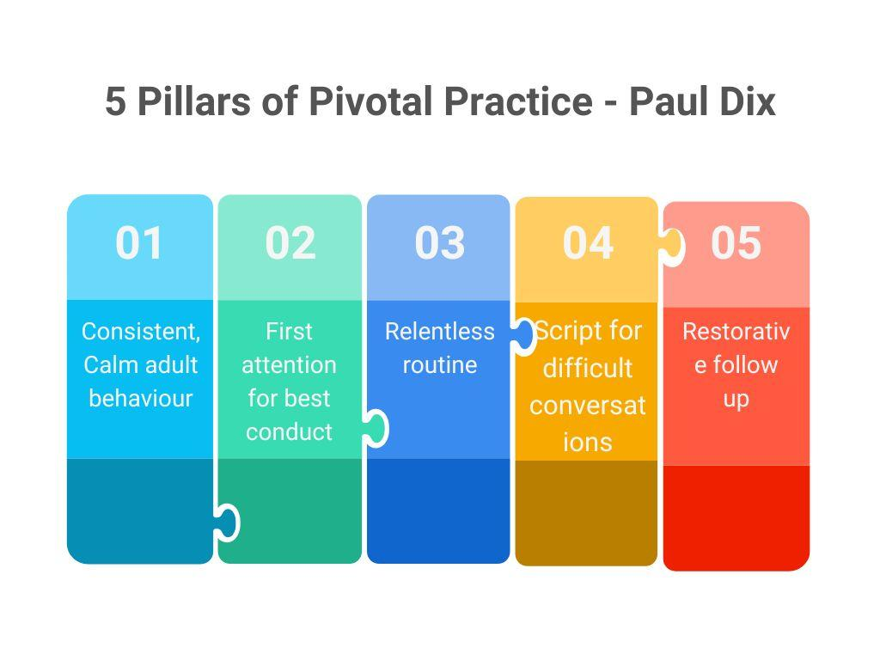

Suspensions and permanent exclusions are the last resort and as a school we are committed to utilising all our available resources to ensure that we have exhausted all proactive and preventative strategies before reaching this point.

At Barton St Peter’s Primary, we have three rules: Be ready, be safe, be respectful however, the primary aim of this policy is not a system to enforce rules. It is a means of promoting good relationships, so that people can work together with the common purpose of helping one another to achieve their best. This policy supports the school community in aiming to allow everyone to work together in an effective and considerate way.

We will always refer to the Christian value of forgiveness when considering negative behaviour and reconcilliation.

We treat behaviour expectations like all other aspects of school life, in line with our Christian vision “ Let your Light Shine” Matthew 5:16
If we’re always ready, there will be no time for disruptive behaviour or time wasting chatter enabling our lights will shine: No one must stop anyone else doing their very best to learn.
When we say ‘look after the school’ we mean people not just the building; Everyone is part of the school. We must show we care in our language, our treatment of others and our actions at all times: Be respectful
Being safe, is the responsibility of everyone in our school community; Teachers, children, parents and beyond. At Barton St Peter’s we believe every member of our community has the right to feel safe in, and out of, school

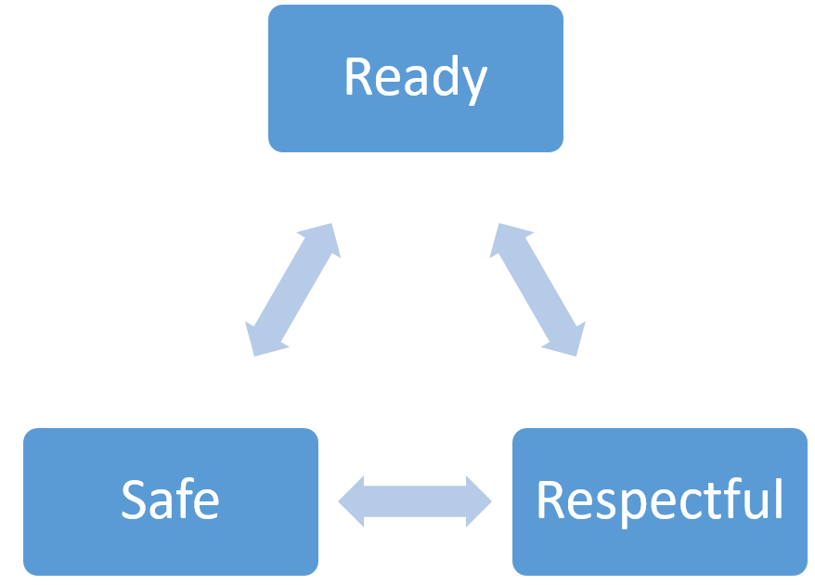
At Barton St Peter’s we place these three rules at the centre of all we do. We also acknowledge the importance of all three rule being achieved in tandem- should one not be achieved, the other two become more difficult to maintain.
If we try our hardest with these three rules, we will be praised and feel proud to be part of Barton St Peter’s School.
This policy applies to all aspects of the school, including Breakfast Club, After School Club and any other additional events held at school, additional to the normal 32.5 hours at school
This policy is written in line with guidance from Government documents (Behaviour and Discipline in Schools: advice for Head Teachers and school staff DFE 2014). The law states that: The Head Teacher must set out measures in the Behaviour Policy which aim to:
• promote good behaviour, self-discipline and respect.
• prevent bullying.
• ensure that children complete assigned work.
• regulate the conduct of students

Shared responsibility
School staff
We expect every adult to:
- Meet and greet every child every morning.
- Refer to the school vision, values and learning expectations in conversation
- Model positive behaviours and build relationships.
- Plan lessons that engage, challenge and meet the diverse needs of pupils with high quality adaptive teaching .
- Use a visible-recognition mechanism throughout every lesson – classroom recognition boards
- Be calm and give 'take up time' when progressing through the steps always aiming for prevention before sanctions.
- Follow up every time, retain ownership and engage in reflective dialogue with pupils.
- Never ignore or walk past pupils who are using poor behaviours.

Senior Leaders

Senior leaders are not expected to deal with behaviour referrals in isolation. Rather they are to stand alongside colleagues to support, guide, model and show a unified consistency to the pupils. Senior leaders will:
- Take time to welcome children and family members at the start of the day
- Be a visible presence around the site and especially at transition times, breaks and lunchtimes
- Celebrate staff, leaders and pupils whose effort goes above and beyond expectations
- Regularly share good practice
- Support staff in managing pupils with more complex or entrenched negative behaviours
- Use behaviour data to target and assess school wide behaviour policy and practice
- Regularly review provision for pupils who fall beyond the range of written policies

Pupils

Pupils are expected to have a positive attitude and maintain high expectations for themselves. Reminders of expected behaviours and standards are up on walls in classrooms and situated around the school.

Rights: All children have the right to learn, to be safe and be happy.
Rules: Rules or codes of behaviour are essential for maintaining the rights.
Responsibility: For their rights to be maintained children have to take on the responsibility of following the rules.

If children break the rules, they must understand that they have chosen to do this and therefore must accept the consequences of their actions, this will be used as a learning opportunity and children will reflect on their behaviour with the support of an adult. Choices will be explained and reinforced as part of teaching responsibility for personal choice, self regulation and behaviour.

We also understand that for some children following our behaviour expectations are beyond their developmental level. In this case, these children will have bespoke positive behaviour plans which may include rewards to reinforce positive behaviour, reinforcing the learning parents/carers instil at home about responsibility.

Parents and Carers:

- Support children at home with their learning and be patient as they develop their understanding
- Be kind and helpful to all children and adults. Be sensitive to the needs and feelings of others
- Have a positive attitude towards the whole school community.
- Reinforce the School Values by rewarding positive behaviour.
- Show an interest in children’s learning.
- Demonstrate the school values at all times and be a positive role model to the children.
- Make sure the children are at school on time every day and ready for learning.
- Communicate regularly with the class teacher.
- Help children prepare for the day, making sure they have all the equipment they need
- Ensure children have good manners
- Encourage children to be kind to everyone
- Monitor children’s use of ICT and mobile phones, regularly checking it
- Attend parents evenings

Positive Strategies

The following positive strategies will be used consistently by all adults in the school. They are designed to ensure 'first attention goes to best conduct' and to create clear, simple routines and expectations that make children feel valued members of our learning community and motivated to always try their best.
Teachers will create a welcoming environment by greeting pupils every morning through a formal meet and greet at the classroom door. This may be a simple, 'Good morning' to provide a consistent check in and enthusiastic welcome for every child.

'The foundation of every school must be excellent behaviour. We should be keeping the focus on a visible culture of impeccable conduct, and making the consistency palpable, audible and highly visible.' Paul Dix

Our rules | Visible consistencies | Over + above recognition
Be safe  Be ready  - Be respectful | - Daily meet and greet  - Persistently capture pupils doing the right thing  - Pick up on children who are failing to meet expectation consistently  - Accompany the children to the playground at break times  - Collect the children from the playground at break and lunchtimes  - Praise in public (PIP)  - Reprimand in private (RIP)  - Consistent language | - Name on the recognition board  - Let Your Light Shine Worship award  - Stickers  - Phone call/text home  - Verbal praise  - Notes/postcards home  - SLT praise  - Class rewards  - Show work to another adult  - Recommendation to Headteacher  - Award of house points

Practical steps in managing and modifying poor behaviour

Pupils are held responsible for their behaviour. Staff will deal with behaviour without delegating. Staff will use the steps in behaviour for dealing with poor conduct. It is the aim that pupils should be kept at steps 1 and 2 for as long as possible. If a child has three or more incidents in a week (or regular incidents) requiring reflection a meeting with SLT and parents/carers will be arranged. This must be recorded on CPOMS.

Sanction | Description | Child Action | Communication to the child | Recording/Sanction | Failure to comply with sanction
Verbal Reminder | A reminder of classroom behaviour expectations delivered privately wherever possible.  ( Praise in public, reprimand in private) | Child makes every effort to regain focus and attempts to meet expectations. | “Remember our expectations: Be Ready, Be Respectful, Be Safe.”  or  “I can see you’re struggling — let’s get back on track.”  ✔ Calm tone  ✔ Give take-up time  ✔ Praise when they reset | No recording of sanction required. | Escalated to Final Reminder
Final Reminder | A child fails to respond positively to the verbal reminder and is then sanctioned with a 1st Warning. A verbal caution delivered privately, if possible, making the pupil aware of their behaviour and clearly outlining the consequences if they continue. | Child may be asked to move seats.  child may be required to have a reset conversation outside of the classroom | Purpose: Clear choice with supportive tone.  Adult uses the 30-second script:  “I have noticed you are…”  ‘At BSP we … (values/expectations)”  “You need to…”  “Think carefully about your next step.”  May include:  ✔ Move seat  ✔ Brief reset/conversation outside the classroom | No recording of sanction required. | Cool off time
Cool off | Cool Off might be a short time away from the classroom with another class/TA/ pastoral / SLT | Child needs to take part in cool down activities eg breathing, a walk, sensory time. | Purpose: Regulate → Reset → Return.  The child takes a short break with:  - TA  - Pastoral  - Another class  - SLT if needed  Focus:  ✔ Breathing  ✔ Regulation  ✔ Sensory tools  ✔ Reflection | No recording of sanction required. | Escalated to 5 minutes pay back time
Reflection time- 5 minutes payback  (last chance 5 minutes after class for a restorative conversation) | A child fails to respond positively to the final reminder and continues to demonstrate behaviours which do not meet the teacher’s expectations. | Child may be asked to move seats.  child may be required to have a reset conversation outside of the classroom  Child loses 5 minutes of the next social time they have | Staff member clearly states the reason for the final warning, using a scripted response: 'Stay behind five minutes after class.' to this step. These two minutes cannot be removed or reduced. | Staff member records 5 minute payback CPOMS  Parent / carer informed | Escalated to Removal
Reflection time- 10 minute payback | A child has persistently disrupted the lesson following a 5 minute payback being issued | Child loses 5 minutes of the next social time they have | Staff member clearly states the reason for the final warning, using a scripted response: 'Stay behind ten minutes after class.' to this step. These minutes cannot be removed or reduced. | Staff member records 10 minute payback on CPOMS and informs parents in order to facilitate a re-set for the next day | Escalated to Intervention / Support
Intervention / Support | A child has now persistently disrupted the learning of other children  Or  A one off incident requiring removal from lesson. | Child is asked to work outside in the corridor or intervention is requested from SLT to isolate the child from their peers. | Staff member clearly states the reason for the final warning, using a scripted response: see 30 sec scripts  Child is taken to the time out room / another class for reflection and appropriate de-escalation / restorative work. | Pastoral or SLT record in CPOMS and an email is sent to parents via ARBOR  If the behaviour links to persistent classroom behaviour, class teacher will need to contact home via phone call on the same day. | Isolation
Isolation | A child has now failed to work productively and cannot return to class without disruption to other children.  OR  A one off incident which is a serious breach of school rules | Child will spend a time in isolation ( internal exclusion) | Staff member clearly states the reason for the final warning, using a scripted response: see script below | Recorded on CPOMS  Email sent to parents via ARBOR  Follow up meeting booked with parents/carers and SLT.

Although sanctions are never taken back there is a strong belief that after a consequence, the issue is resolved and a fresh start must be given. This encourages students to learn and develop the skills, tools and knowledge for self-regulation and behaviour.

Categorising behaviour
Low Level Behaviours  May Include: | Medium Level Behaviours  May Include: | High Level Behaviours  May include:
Pushing in  Teasing  Interrupting teacher  Attention seeking  Clowning around  Spoiling the games of others Telling tales  Avoiding work  Wasting time/Being noisy Running  Arguing | Repetition of Level 1 behaviour Answering back/arguing/being cheeky to staff  Lying  Biting (age appropriate) Graffiti  Pushing about with hands and feet  Hitting back  Refusal to complete work Complete refusal to follow instructions  Damaging resources | Bullying  Vicious kicking Fighting/thuggery  Endangering others and themselves  Throwing of furniture Swearing at staff/peers  Racial or homophobic abuse Stealing  Physical abuse of staff/pupils Verbal abuse of staff/pupils Other unacceptable behaviour outlined in Section 6.6

30 second script:

Speak to the pupil privately and give them a final opportunity to engage. Use the 30 second scripted intervention
- I have noticed that you are...(having trouble getting started, wandering around etc.) right now.
- At BSP, we… (refer to expectations)
- Because of that you need to... (refer to action to support behaviour e.g. moving to another table, complete learning at another time)
- See me for 5 minutes after class/during break
- Do you remember yesterday/last week when you... (refer to previous positive behaviour) this is what we want to see from you again. That is who I need to see today...
- Thank you for listening... then give the child some ‘take up’ time. If the warning is not heeded and the behaviour continues this must be recorded
- At this point the learner will be informed that they will have to miss ten minutes from the next break/lunch time in reflection time.
- Children will be expected to have a reflective dialogue.
- For serious breaches at lunch times, the pupil will be expected to stay inside with an adult for a portion of their lunch break and all parties involved will take part in a restorative dialogue.

Repair Restorative Conversation

Restorative Practice can be used to promote good behaviour and resolve unacceptable behaviour in a fair and consistent way. Any form of humiliation or sarcasm is not acceptable. Every effort will be made to maintain safety and retain all children’s access to learning. Efforts will be made to establish the truth of a situation and a ‘cooling down’ period may be advisable. However, issues must be addressed appropriately and promptly. Decisions regarding consequences must be considered, reasonable and not made on impulse. If behaviour is disruptive, teachers will apply the procedures from the steps detailed above.
5 questions is usually enough from the following:
- What happened?
- What were you thinking at the time?
- What have you thought since?
- How did this make people feel?
- Who has been affected?
- How have they been affected?
- What should we do to put things right?
- How can we do things differently in the future?

Imposition given if needed (An imposition is additional work that must be completed that evening, countersigned by parent and returned first thing. This is to help the child to understand that there are consequences and the responsibility for making up time lost is with them not the teacher)

Serious incidents

Depending on the age of the children these incidents will be dealt with at the discretion of the school staff. All serious behaviour matters must be referred immediately to the Headteacher or SLT.
Such incidents could include:
- Fighting
- All forms of bullying
- Racist, sexist or homophobic comments
- Inappropriate name calling
- Using abusive/offensive language
- Physically striking adults.

Fixed Term suspensions

At BSP we believe that, in general, exclusions are not an effective means of moving behaviour forward. However, in order for children to achieve their maximum academic potential in the school they must feel safe from physical and verbal aggression and disruption. If a child seriously breaches the school’s behaviour policy and if the pupil remaining in school would seriously harm the education or welfare of the pupil or others in the school, the Headteacher may take the decision to suspend for a fixed period. ( 1-5 days) If this decision is taken, work will be set for the pupil to complete at home. Following fixed-term suspension, the pupil and parents will meet with the Headteacher to discuss the pupil’s reintegration to school and the best way forward to support the child to avoid future suspensions. Each day is a new day and where a child has transgressed it is expected that they will be welcomed and treated without any resentment when they return. The decision to suspend a student will be taken on a balance of probabilities and will take into account the seriousness of breaches of the school's Behaviour Policy, including persistent disruptive behaviour. If behaviours continue to disrupt the school may seek for children to move to an alternative setting; this may be a managed move to another school or placement in a specialist behaviour provision.

**A student consuming or dealing in prohibited substances or brandishing an offensive weapon can expect to be permanently excluded. In these situations, the Police will be informed immediately and asked to attend the school.

Reintegration Meeting
A reintegration interview will be arranged with the parent/carer during or following the expiry of any suspension. The aim of the reintegration interview is to assist the reintegration of the student by:
- Establishing understanding of behaviour expectations
- Identifying the support and intervention needed at school and home to ensure an improvement in behaviour
Part Time Timetables
There are times when a student requires a reduction in their timetable in order to support them in managing expectations within school and to ensure a positive outcome. This is done in collaboration with parents/carers and is for a fixed period of time, with regular reviews.

Permanent Exclusion
The Secretary of State for Education feels that permanent exclusion should be seen as a last resort and that a school should be able to show that it has taken all reasonable steps to avoid exclusion (See Exclusion Regulations). The governors of BSP agree with this stance and all policies and procedures are in place to support inclusion of all pupils. Permanent exclusion should only occur when risk assessment indicates that to allow the child to remain in school would be seriously detrimental to the education or welfare of the pupil concerned, or to other pupils at the school. A permanent exclusion is when a student is no longer allowed to attend the school (unless reinstated). The decision to permanently exclude a student is made by the Headteacher and should only be taken:

- in response to a serious breach or persistent breaches of the school’s behaviour policy; and
- where allowing the pupil to remain in school would seriously harm the education or welfare of the pupil or others such as staff or pupils in the school.
There are occasions when a fixed term suspension has been issued and then further evidence has come to light which would mean the decision is now a permanent exclusion. In this rare occurrence, the permanent exclusion will be implemented following the fixed term suspension.
There is not an exhaustive list of behaviours which would constitute a permanent exclusion as it is at the Headteacher's discretion as to if the incident(s) meet the above criteria. However, there are some behaviours which will automatically result in a permanent exclusion:

- A student consuming or dealing in prohibited substances on the school site
- A student brandishing an offensive weapon of any kind
- A student who maliciously sets off the fire alarm, knowing that public examinations are taking place
- Serious physical assault of another student or a member of staff
- Gratuitous damage to the school building/ furniture
Exclusion Appeals
Fixed term suspension appeal process is documented within the suspension letter.
Permanent exclusions will result in a Governing Body Disciplinary Committee being held in response to the Headteacher’s decision. The committee’s role is to decide whether to direct reinstatement. The committee meeting provides an opportunity for parents/carers and professionals to present their evidence in support of this.
Full details of the Committee hearing will be communicated to parents through the clerk following the issuing of the permanent exclusion letter.

Positive handling (Restrictive Interventions, including Reasonable Force)

Providing a safe environment for children to learn in is of paramount importance to us. If a child’s behaviour endangers the safety of others or themselves, or the behaviour is having an adverse effect on the learning of other pupils, the child will be removed from the classroom/ area using appropriate positive handling strategies.
All members of staff are aware of the regulations regarding the use of force, as set out in the DfE Guidance ‘Restrictive interventions, including use of reasonable force’ (April 2026), relating to Section 93 and 93A of the Education and Inspections Act 2006. Reasonable means using no more force than is necessary, proportionate and for the least amount of time.
As stated in the guidance:
All members of school staff have a legal power to use reasonable force in certain circumstances.
To prevent or stop a pupil from:
- causing injury to themselves or others
- committing a criminal offence
- damaging property
- causing disorder among pupils receiving education at school, whether during a teaching session or otherwise.

We would always seek to employ non-verbal and/or verbal interventions such as distraction or humour before the use of Positive Handling techniques where physical interventions are required. All incidents that require positive handling approaches will be recorded appropriately by the members of staff involved and logged on CPOMs. The incident will be communicated to parents / carers via a phone call. We endeavour to do this on the same day. This will then be followed by a letter providing a written report. Parents will also have the opportunity to come into school for a face-to-face meeting should they so wish.
The Rainbow Room, Pastoral Room or SEN Room would be the main areas which children presenting these challenging behaviours may be escorted to. They provide an environment in which children can be supervised as they regulate safely and in their own time. Whilst in these spaces communication continues and children are encouraged and supported to regulate, ready for reintroduction to the classroom. In cases where this type of intervention is more regular and part of a pupils Individual Behaviour Plan, a Positive Handling Plan will also be written, reviewed and shared with parents.
The DfE guidance states that ‘Schools should not have a ‘no contact’ policy. Schools should not grant any requests by parents or staff members not to use reasonable force and / or other restrictive interventions.’ This is due to the expectation that staff intervene to fully protect pupils.
Preventing Recurrence of Misbehaviour

We have a range of initial intervention strategies to help students manage their behaviour and reduce the likelihood of suspension. This is based on ensuring students have a good understanding of behavioural expectations and providing support to ensure they develop the skills and tools to meet them.

The support each student needs is bespoke to them and is implemented in collaboration with parents/carers for maximum effect. The support must extend into the home to ensure that school and parents/carers are working consistently in establishing the behavioural expectations.

Examples of support include:

- Parental/carers meetings and home visits
- Parenting assessments
- Mentoring and coaching
- Behaviour reports
- Behaviour support plans
- Focused 1-1 or small group interventions with the pastoral team on specific issues such as Anger Management for example

In establishing the underlying need behind the behaviour, staff are trained to assess any SEND need that a student may have. This way our SENDCo can work directly with any student whose behaviour is causing concern, if a SEND need is identified.
If there are serious concerns with a student’s behaviour and there is no improvement through school-led interventions and support, then a multi-agency approach will be needed. This will mean that the school will seek professional advice and support from a range of partners such as:

- Behavioural Support Team;
- Social Care:
- Educational welfare;
- Police
- Education Inclusion team;
- Child Adolescent Mental Health Service (CAMHS)
- Headway Outreach Support

If a child leaves the school grounds without permission

Every effort should be made to encourage the child back in to school. If a child chooses to leave the school premises, they should not be followed, as this could risk the child taking flight and running into traffic. A clear command of “Stop, you are putting yourself in danger,” should be shouted. The member of staff should return immediately to the school office and contact parents/carers. They should be given the choice of trying to retrieve the child themselves or ringing the police. If no parent/carer is available the police will be informed. A member of the Leadership Team should be informed as soon as possible

Confiscation of inappropriate items and the power to search

The general power to discipline enables a member of staff to confiscate, retain or dispose of a pupil’s property as a punishment, so long as it is reasonable in the circumstances. The law protects them from liability for damage to, or loss of, any confiscated items provided that they have acted lawfully. Confiscated items will be retained until the end of the school day or the carer collects them dependent on the nature of the item confiscated. Staff have the power to search without consent for “prohibited items” including: knives and weapons, alcohol, illegal drugs, stolen items, tobacco, fireworks, pornographic images, any article that has been or is likely to be used to commit an offence, cause personal injury or damage to property, any item banned by the school rules (i.e. mobile phones). Staff may also use reasonable force as is reasonable given the circumstances when conducting a search without consent. Weapons, drugs and extreme or child pornography must always be handed over to the police.

Beyond the school gate

The school policy may be imposed even in relation to misbehaviour which takes place outside school premises, where it is witnessed by a staff member or reported to the school.
- This includes when the pupil is:
- taking part in any school-organised or school-related activity;
- travelling to and from the school;
- wearing the school uniform;
- in some other way identifiable as a pupil at the school.

or misbehaviour at any time, whether or not the conditions above apply, that:
- could have repercussions for the orderly running of the school;
- poses a threat to another pupil or member of the public;
- could adversely affect the reputation of the school.

In all cases of misbehaviour off the school site, staff can only address with the pupil on school premises or elsewhere when the pupil is under the lawful control of the staff member such as on school visits. Parents will be informed of any incidents of this nature.

Support for Children with SEND

A Behaviour Support Plan will be used for children with SEND whose condition causes them to display challenging behaviour and advice will be sought from external agencies where necessary to assist with putting in place appropriate support strategies, which will be monitored and reviewed. Please read the School’s Special Educational Needs Policy and SEN Information Report for more information. The school will as far as possible, anticipate likely triggers of misbehaviour for pupils identified as having SEND and will put in place support to prevent these. Examples of preventative measures include (but are not limited to):
∙ carefully planned timetables, taking into account any SEND needs (identified through IEP or EHCP), including sensory breaks and planned time out the classroom
∙ short, planned movement breaks for a pupil whose SEND means that they find it difficult to sit still for long;
∙ adjusting seating plans to allow a pupil with visual or hearing impairment to sit in sight of the teacher;

Staff training will include matters such as how certain special educational needs, disabilities, or mental health needs may at times affect a pupil’s behaviour. Where relevant, engagement with experts, such as Educational Psychologists and other support staff such as counsellors and Mental Health Support Teams, can help to inform effective implementation of this policy.

Adeline Brack
January 2026

