EYFS  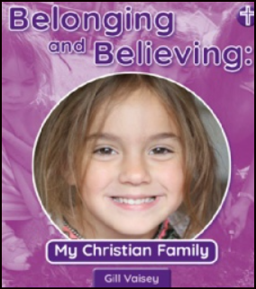  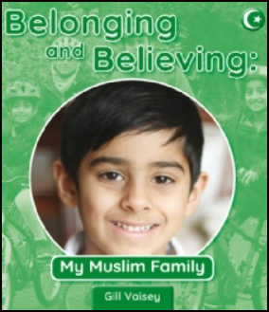  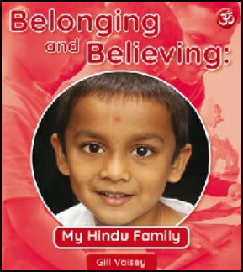 | LAS Unit  Myself  [Introduce people who belong to a religious group]  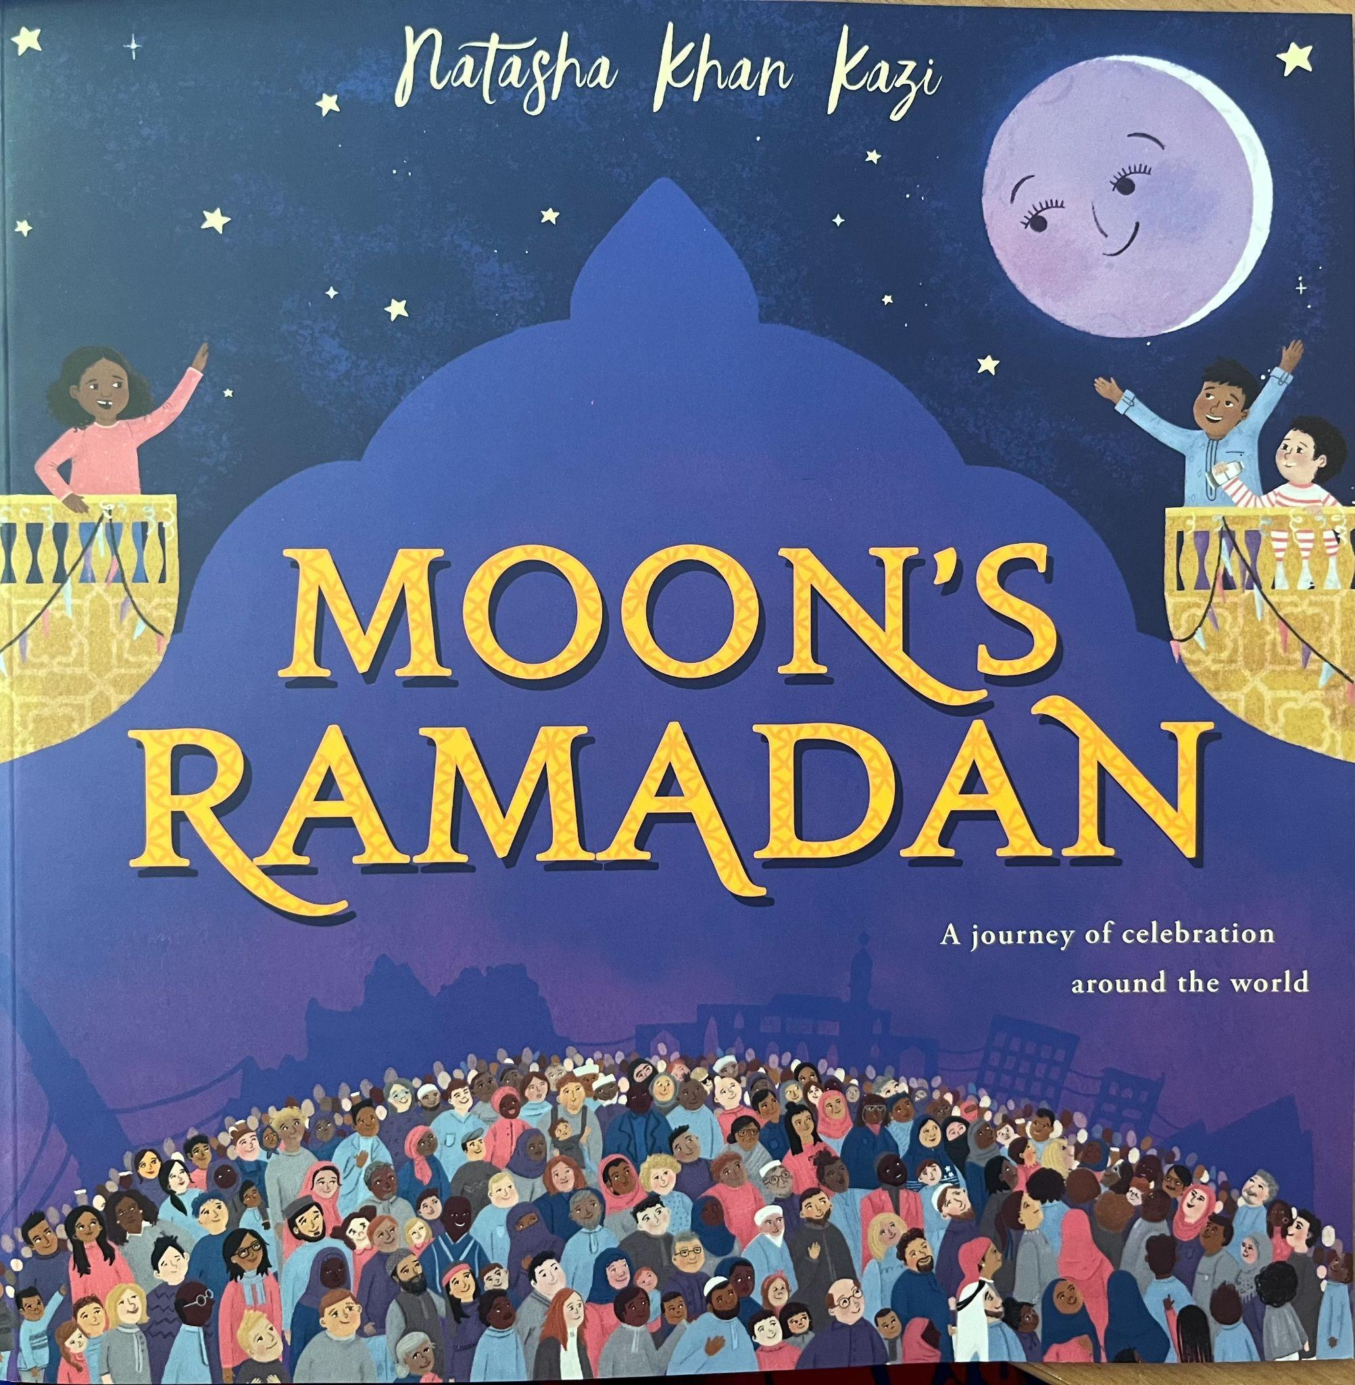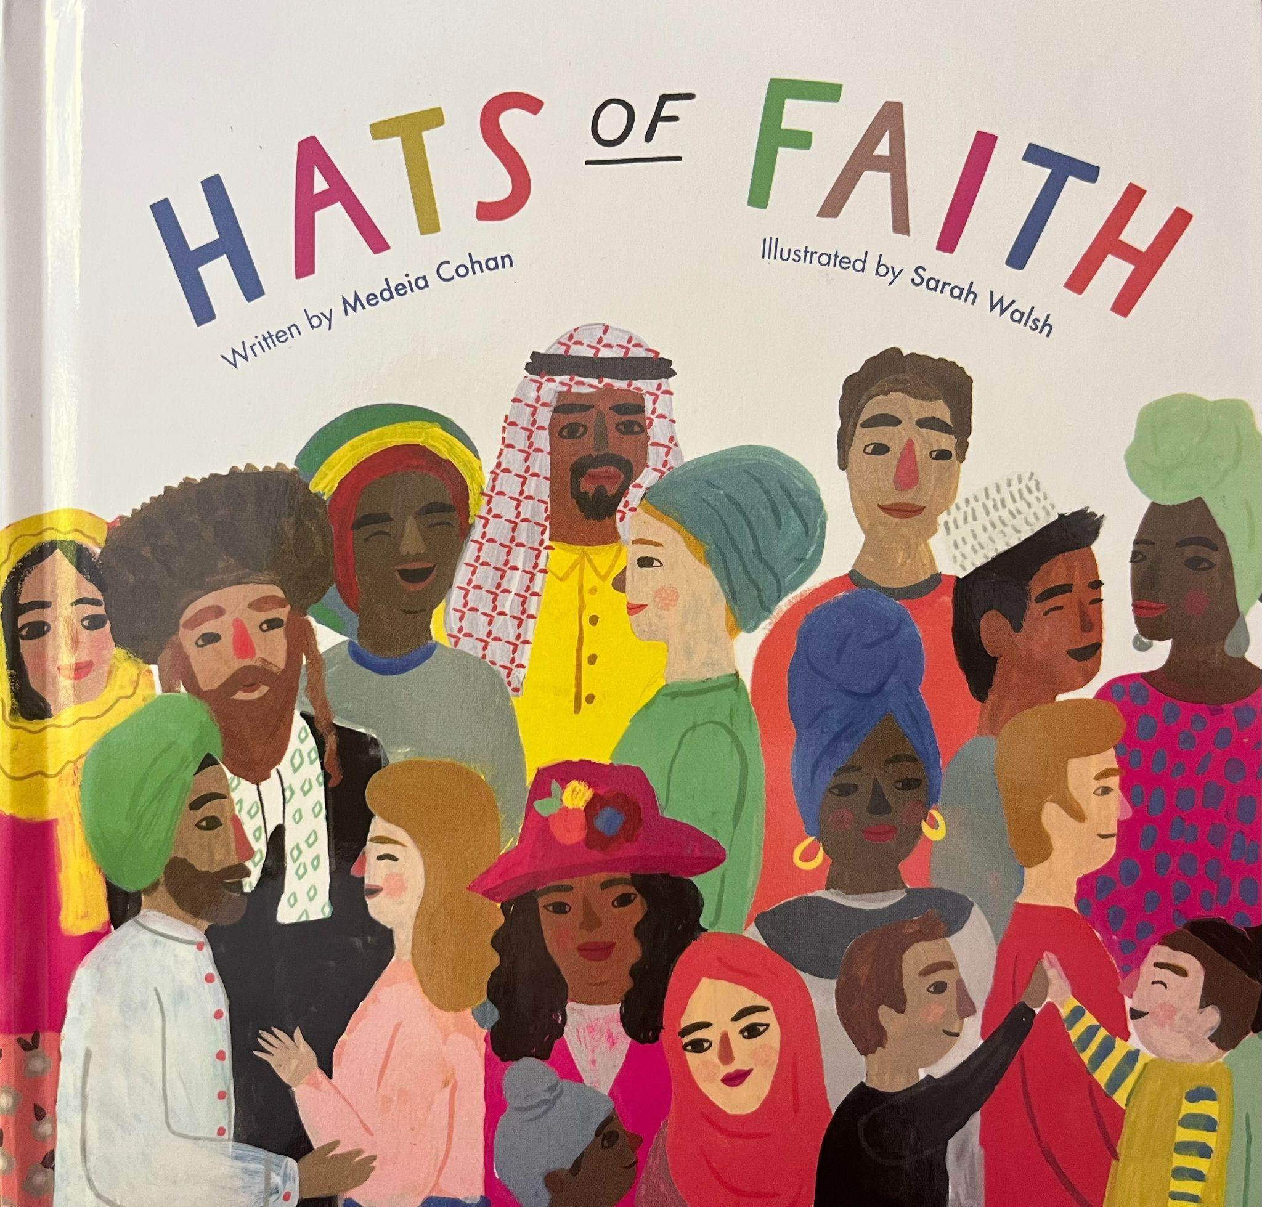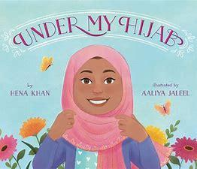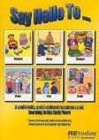 | LAS Units  Special people to me  [Introduce people who are important to members of a religious group, e.g. Jesus, Prophet Muhammad, vicar, imam] | LAS Unit  Our special books  [Introduce stories from religions and important books for members of a religious group]  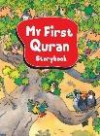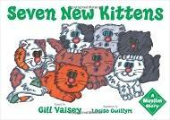 | UC - Salvation  UC F3 (core)  Why do Christians put a cross in an Easter garden?  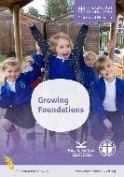 | UC - Creation  UC F1 (core)  Why is the word ‘God’ so important to Christians? | LAS Unit  Our beautiful world  [Introduce stories about creation and some beliefs about the natural world, e.g. the duty to care for the environment]  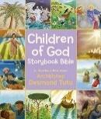
Incarnation
UC F2 (core)
Why do Christians perform Nativity plays at Christmas?
KS1 A  Sept 2022 | UC - God  UC 1.1 (core)  What do Christians believe God is like?  Christian visitor | UC - Creation  UC 1.2 (core)  Who do Christians believe made the world?  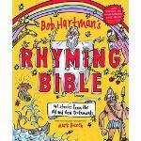 | LAS Compulsory  God – Islam  [How is Allah described in the Qur’an?  What do Muslims learn about Allah and their faith through the Qur’an?]  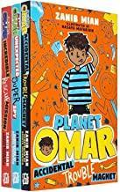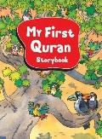 | LAS Compulsory  Community – Islam  [What do Muslims do to express their beliefs?  Which celebrations are important to Muslims?]  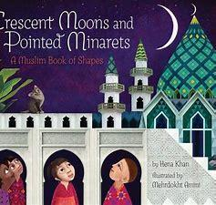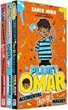 | LAS Additional  Places of worship  [Choose three key objects, features or symbols and look at:  - what they tell us about beliefs about God/humans/the world around them  - how they are used in practice – i.e. what impact they have on the community  Non-negotiable: Christianity plus Additional = Hinduism  St Mary’s Church visit
KS1 B  Sept 2023 | LAS Compulsory  Being Human – Islam  [What does the Qur’an say about how Muslims should treat others and live their lives?  How can Muslim faith and beliefs be seen in the actions of inspirational Muslims?]  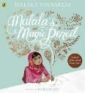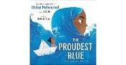 | LAS Compulsory  Life Journey – Islam  [What do Muslims do to celebrate birth?  What does it mean and why does it matter to belong?] | LAS Additional  Thankfulness  (E.g. harvest in Christianity]  Non-negotiable: Christianity plus Additional = Hinduism  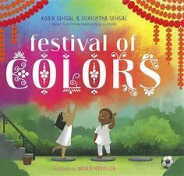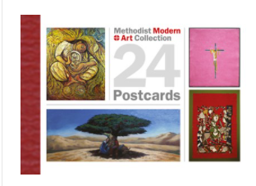 |  | UC - Salvation  UC 1.5 (core)  Why does Easter matter to Christians? | UC - Incarnation  UC 1.3 (core)  Why does Christmas matter to Christians?

LKS2 A  Sept 2022 | LAS Compulsory  God – Hinduism  [How are deities and key figures described in Hindu sacred texts and stories?  What might Hindus understand about the Divine through these stories? What is the purpose of visual symbols in the mandir?]  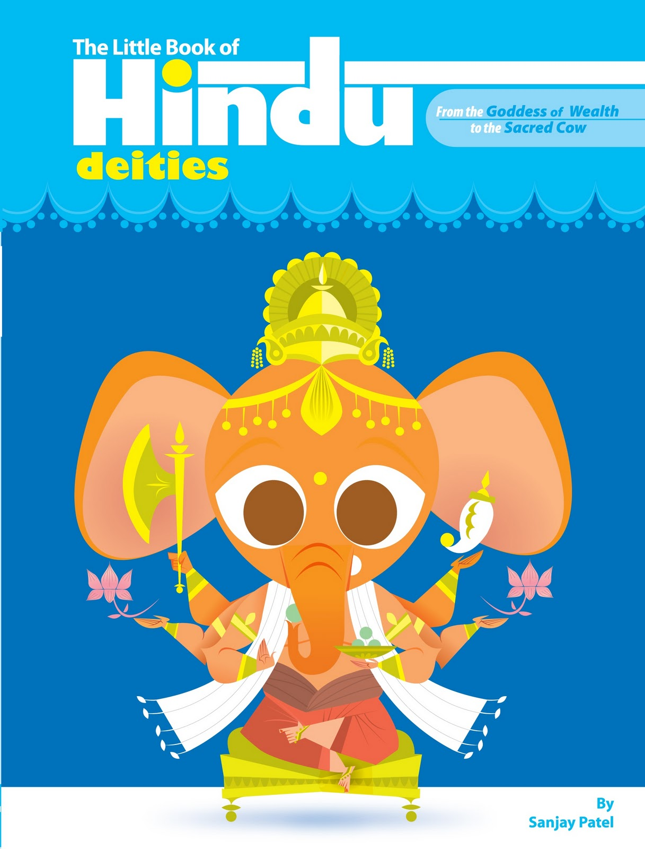  Indri – Hindu workshop | LAS Compulsory  God – Islam  [What do the main concepts in Islam reveal about the nature of Allah? What is the purpose of visual symbols in a mosque?]  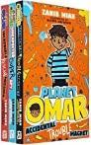  Mosque Visit – Pakistan Islamic Centre | UC - God/Incarnation  UC 2a.3 (core and digging deeper)  What is the Trinity?  Christian visitor |  | UC - Salvation  UC 2a.5 (core)  Why do Christians call the day Jesus died ‘Good Friday’? | LAS Additional  Big Questions (including Christianity):  What does it mean to live a good life?  [Opportunity to look at guidelines and laws in various religions and non-religious worldviews. Chance to explore whether ‘good’ means the same thing to everybody]  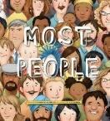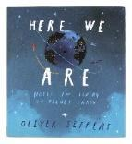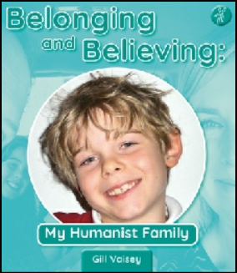  Non-negotiable: Christianity plus Additional = Humanism
LKS2 B  Sept 2023 | LAS Additional  Big Questions (including Christianity):  Why do we celebrate?  [What different events/times of life do we celebrate?  How do different people celebrate things differently?  How does celebration relate to remembrance?]  Non-negotiable: Christianity plus Additional = Humanism | LAS Compulsory  Community – Hinduism  [How is Hindu belief expressed personally and collectively? How does Hindu worship and celebration build a sense of community?  Worship and celebration. Ways in which worship and celebration engage with/affect the natural world. Beliefs about creation and natural world] | LAS Compulsory  Community –Islam  [How is Muslim worship expressed collectively? How does Muslim worship and celebration build a sense of community?  Worship and celebration. Ways in which worship and celebration engage with/affect the natural world. Beliefs about creation and natural world] 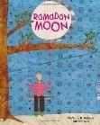 | UC - Creation  UC 2a.1 (core)  What do Christians learn from the creation story? | LAS Additional  Pilgrimage  [What is a pilgrimage? What does pilgrimage involve? E.g. Christian pilgrimage to Walsingham, Lourdes, Iona, Jerusalem, Muslim pilgrimage to Makkah, Hindu pilgrimage to the Ganges, etc. Environmental impact of pilgrimage]  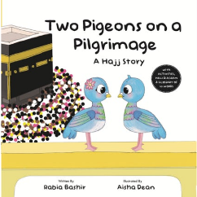  Non negotiable: Christianity plus Additional = Humanism (Map sources of the Golden Rule on a map?)  Mr Kotwal – Hajj workshop

UKS2 A  Sept 2022 | LAS Compulsory  Being Human – Hinduism  [How do Hindus reflect their faith in the way they live? What is karma and how does it drive the cycle of samsara? How might a Hindu seek to achieve moksha?  The ways in which beliefs impact on action: expectations of behaviour, ways in which people act, examples of contemporary individuals] | LAS Compulsory  Being Human – Islam  [What does the Qur'an teach Muslims about how they should treat others? How do Muslim teachings guide the way Muslims act in the world? How are Muslim beliefs expressed in practice?  The ways in which beliefs impact on action: expectations of behaviour, ways in which people act, examples of contemporary individuals]  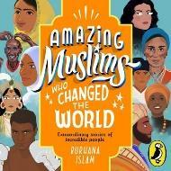 | UC - Salvation  UC 2b.7 (core)  What difference does the resurrection make for Christians?  [How do Christians behave/act because of their beliefs about Jesus and the resurrection?] |  | UC - Incarnation  UC 2b.4 (core)  Was Jesus the Messiah?  [Was Jesus who he said he was? Did the resurrection happen? Does it matter if it didn’t?]
UKS2 B  Sept 2023 | UC - Creation  UC 2b.2 (core)  Creation and Science: Conflicting or Complementary?  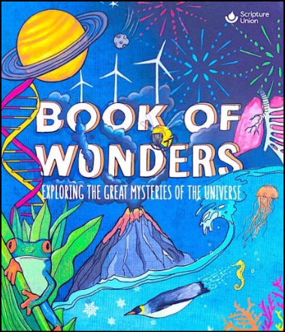 | UC - Creation  UC 2b.2 (digging deeper)  Creation and Science: Conflicting or Complementary? | UC - God  UC 2b.1 (core)  What does it mean if God is loving and holy?  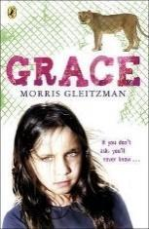 | LAS Additional  Do you have to believe in God to be good?  [Opportunity to study and explore e.g. issues of social justice]  Humanist Visitor  Non-negotiable: Christianity plus Additional = Humanism | LAS Compulsory  Life Journey – Hinduism/Islam  [Hinduism: How do Hindus show they belong? | Islam: How do Muslims show they belong?  Rites of passage; include other religions, e.g. Bar/Bat Mitzvah in Judaism, confirmation in Christianity; have looked at how we know whether religious claims are true or not – this unit considers whether their truth or otherwise actually matters – what impact does religion have on people’s lives, regardless of whether they can prove their beliefs to be true or not]
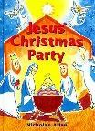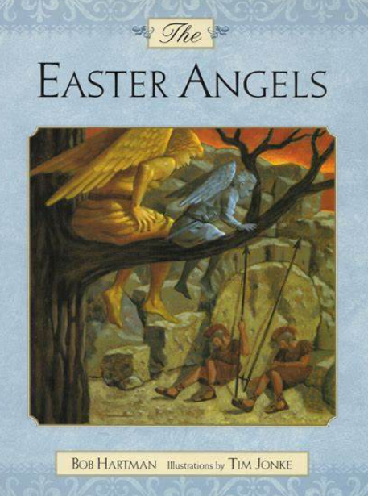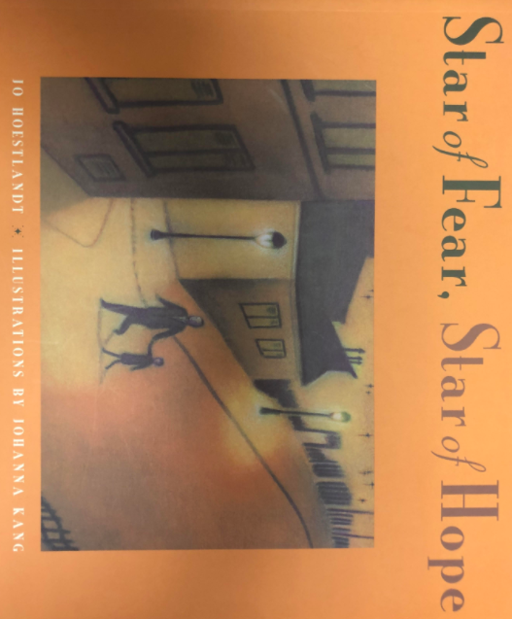

Opportunities for linked writing for purpose

Year  1 and 2 | Autumn Poem  Labelling  Story planning and writing  Setting and character descriptions  Letters  Instruction  Recount | Autumn poem  Instructions  Recount  Character descriptions  Setting descriptions  Letters  Labels and caption  Story planning / writing  Retell a simple story Year 2 Write a sequel to a known story | Story Retell  Write a new part to a familiar story  Describe a setting  Instructions writing in role( 1st person)  Write a seasonal poem  Write a thank you letter  Non chronological report | Write a seasonal poem  Instruction writing  Creative writing  Descriptive writing using senses  Diary entry  Role play  Sequencing and retelling a story  Alternative ending,  Fact file / factual report | Labels and captions Instructions  Non fiction writing Factfile  Description of setting  Description of a character Narrative - Story writing - retell , alternative/ new version  Explanation text  Recount | Instruction writing  Diary entry  Description  Discussion  Explanation  Fact file  Diary entry,  Thank you letter
Year  3 and 4 | Narrative  Recount  Newspaper report Poetry  Biography | Kenning  Poetry  Recount  Job application  Diary entry  Newspaper report  Adventure story | Instructions  Adventure story  Animation story, Newspaper report  Playscript | Poetry  Newspaper report  Diary entry  Debate  Non-chronological reports  Explanation text | Poem  Explanation Text Instructions  Non-Chron Reports  Persuasion, Information Text  Narrative | Poetry  Narrative  Play scripts  Explanation texts  Persuasion/debate  Newspaper report
Year  5 and 6 | Narrative  Recount  Poetry  Discussion  Persuasion  Myth | Myth/narrative  Recount  Poetry  Persuasion  Explanation  Discussion  Character narrative/ description | Poetry Biography Narrative Journalistic recount Letter/argument Explanation Discussion Instructions | Poetry  Narrative  Journalistic recount  Discussion text  Letter to argue  Explanation text  Diary (recount) | Narrative  Poem  Play, Letter Explanation Journalistic recount | Poetry  Instructions  Narrative  Recount  Biography  Non-chronological report

