
Let Your Light Shine
Matthew 5:16

MEDICAL POLICY

Review : October 2026
Reviewed by: AJB

Barton St Peter’s Church of England Primary School
SUPPORTING PUPILS AT SCHOOL WITH MEDICAL CONDITIONS – POLICY AND PROCEDURE

Headteacher: Miss A Brack
Designated Governors: Mrs Su Burman
SENCO: Miss J Winney

Date: November 2025 Review Date: Autumn Term 2026

Legislative background

At Barton St Peter’s Church of England Primary School we recognise and will meet our duties and responsibilities in relation to supporting pupils at school with medical conditions. These duties and responsibilities are contained in the legislation and statutory guidance listed below:

- Department for Education’s statutory guidance – ‘Supporting pupils at school with medical conditions’ April 2014 (updated June 2014) – governing bodies, proprietors and management committees must have regard to this guidance in order to meet the duty/responsibilities of the Children and Families Act 2014.
- Children and Families Act 2014 (Section 100) – places a duty upon governing bodies of maintained schools, proprietors of academies and management committees of PRUs to make arrangements for supporting pupils at their school with medical conditions.
- Equality Act 2010 – some children with medical conditions may be disabled. Where this is the case governing bodies must comply with their duties under the Equality Act 2010.
- Special Educational Needs and Disability (SEND) Code of Practice July 2014 – some children with medical conditions may also have special educational needs (SEN) and may have a Statement, or Education, Health and Care (EHC) Plan. For children with SEN this policy/procedure statement should be read in conjunction with school SEN policies and the SEND Code of Practice.
- Human Medicines (Amendment No. 2) Regulations 2014 – allows schools to hold stocks of asthma inhalers containing salbutamol for use in an emergency. These regulations come into effect on 1October 2014.

Introduction

At Barton St Peter’s Church of England Primary School children with medical conditions, in terms of both physical and mental health, will be appropriately supported in school so that they can play a full and active role in school life, remain healthy and achieve their academic potential. Children with medical conditions will be encouraged and supported to access and enjoy the same opportunities at school as any other child.

We recognise that pupils with long-term and complex medical conditions may require on-going support, medicines or care whilst at school to help them to manage their condition and keep them well. Others may require monitoring and interventions in emergency circumstances. Barton St Peter’s Church of England Primary School recognises that each child’s needs are individual.

We also recognise that needs may change over time, and that this may result in extended absence from school. The school will make every effort to minimise the impact upon a child’s educational attainment and support his or her emotional and general well-being, including any necessary re-integration programmes. The school will strive to give pupils and their parents’ confidence in the school’s approach.

The school recognises that some children who require support with their medical conditions may also have special educational needs and may have a Statement or Education, Health and Care (EHC) Plan – also introduced by the Children and Families Act 2014. We will work together with other schools, health professionals, other support services, and the Local Authority. Sometimes it will be necessary for the school to work flexibly, for example, by means of a combination of attendance at school and alternative provision/personalised learning.

Policy arrangements

- The Headteacher, Miss A Brack, will ensure that sufficient staff are suitably trained.
- All relevant staff including supply and other temporary staff will be made aware of the child’s condition.
- Cover arrangements will be put into place to cover for staff absence to ensure appropriate provision is always available.
- Risk assessments will be put into place for educational visits, and other school activities outside the normal timetable, and
- Individual Healthcare Plans (IHPs) will be monitored and involve appropriate health care professionals.

Procedure to be followed when notification is received that a pupil has a medical condition

The school, in consultation with all relevant stakeholders including parents, will:

- Ensure that arrangements are put into place to cover transition from another setting, upon being notified that a child is coming into school with a medical condition. These may vary from child to child, according to the existing IHP.
- Ensure that arrangements are implemented following reintegration into the school or when the needs of a child change.
- Put arrangements into place in time for the start of the new school term.
- In other cases, such as a new diagnosis or children moving to a new school mid-term, make every effort to ensure that appropriate arrangements are in place within two weeks.
- Provide support to pupils where it is judged by professionals that there is likely to be a medical condition.
- Ensure that any staff training needs are identified and met.

Individual Healthcare Plans (IHP)

The Headteacher will normally be responsible for developing IHPs – in liaison with, and with appropriate oversight of, a relevant healthcare professional (e.g. school nurse/nurse specialist – diabetes/epilepsy/paediatrician, etc.). The purpose of an IHP is to ensure that there is clarity about what needs to be done, when and by whom. An IHP will often be essential, such as in cases where conditions fluctuate or where there is a high risk that emergency intervention will be needed, and they are likely to be helpful in the majority of other cases, especially where medical conditions are long-term and complex and require specific management. However, not all children will require an IHP. The school, healthcare professionals and parents will agree, based upon evidence, when an IHP would be inappropriate or disproportionate. If consensus cannot be reached, the Headteacher will take a final view. A flow chart for agreeing the support required is provided in Annex A and a template IHP is provided in Annex B. Input from a healthcare professional must be provided.

The IHP is confidential to the school but, with parental permission, will be shared with staff throughout the school. The level of detail within an IHP will depend upon the complexity of the child’s condition and the degree of support needed. Where a child has a special educational need, but does not have a Statement or EHC Plan, their special educational needs will be referred to in their IHP. (Not all children with special educational needs need IHPs – they have individual educational plans or IEPs.)

IHPs, and their review, may be initiated, in consultation with the parent, by a member of school staff or a healthcare professional involved in providing care for the child. IHPs will be drawn-up in partnership between the school, parents, and a relevant healthcare professional, e.g. Specialist or Community/School Nurse/other health professional. Wherever possible, the child should also be involved in the process. The aim is to capture what needs to be done to help staff and the child manage their condition and overcome any potential barriers to getting the most from their education. Responsibility for ensuring the plan is finalised rests with the school.

IHPs will be reviewed at least annually or more frequently if evidence is presented that the child’s needs have changed. IHPs are devised with the child’s best interests in mind, ensuring that an assessment of risk to the child’s education, health and social well-being is managed minimising disruption. Reviews will be linked to any EHC Plan/Statement, as appropriate.

Information to be recorded

When deciding upon the information to be recorded on Individual Healthcare Plans (IHPs), the following will be considered:

- The medical condition, its triggers, signs, symptoms and treatments.
- The pupil’s resulting needs, including medication (dose, side-effects and storage) and other treatments, time, facilities, equipment, testing, access to food and drink where this is used to manage their condition, dietary requirements and environmental issues. E.g. Crowded corridors, travel time between lessons.
- Specific support for the pupil’s educational, social and emotional needs. E.g. exams, use of rest periods or additional support in catching up with lessons, counselling sessions.
- The level of support needed, including in emergencies. If a child is self-managing their medication, this should be clearly stated with appropriate arrangements for monitoring.
- Who will provide the support, their training needs, expectations of their role and confirmation of proficiency to provide support for the child’s medical condition from a healthcare professional; and cover arrangements for when they are unavailable.
- Who in the school needs to be aware of the child’s condition and the support required.
- Arrangements for written permission from parents and the Headteacher for medication to be administered by a member of staff, or self-administered by the pupil during school hours.
- Separate arrangements or procedures required for school trips or other school activities outside of the normal school timetable that will ensure the child can participate, e.g., appropriate Risk Assessments.
- ‘What to do in an emergency’, including whom to contact and contingency arrangements. Some children may have an emergency healthcare plan prepared by their lead clinician that could be used to inform the development of their school IHP.
- Informing/sharing appropriate IHP information with other relevant bodies (e.g. Home to School Transport) – through appropriate agreement/consent.

Roles and responsibilities

Supporting a child with a medical condition during school hours is not the sole responsibility of one person. The school will work collaboratively; both with staff within the organisation and with outside agencies, as the circumstances of each child dictate.
Governing Body

The Governing Body will ensure that:

- Pupils in school with medical conditions are supported.
- This policy is reviewed at least annually, developed, implemented and monitored.
- Staff receive suitable training and that they are competent before they take on the responsibility to support children with medical conditions.
- There are quality assurance systems in place to ensure that pupils in school with medical conditions are supported (e.g. case monitoring/assurance audits).

Headteacher

The Headteacher has overall responsibility for the development of Individual Healthcare Plans (IHPs). The Headteacher will ensure that:

- The Supporting Pupils at School with Medical Conditions Policy/Procedure is developed and effectively implemented with partners, including ensuring that all staff are aware of the policy and that they understand their role in implementing the policy.
- The Headteacher will ensure that all staff who need to know are aware of a child’s medical condition.
- Sufficiently trained staff are available to implement the policy and deliver against all the IHPs, including in contingency and emergency situations.
- Ensure that all staff are appropriately insured to support pupils in this way.
- Liaise with the school nurse in respect of a child who has a medical condition, including in cases where the situation has not yet been brought to the attention of the school nursing service.

School Staff

Any sufficiently trained member of the school staff may be asked to provide support to pupils with medical conditions, including the administration of medicines.

Any member of school staff should know what to do and respond accordingly when they become aware that a pupil with a medical condition needs help.

Pupils

Pupils with medical conditions may be best placed to provide information about how their condition affects them. They will be involved in discussions about their medical support needs and contribute as much as possible to the development of, and review of, their IHP. Other children will often be sensitive to the needs of those with medical conditions and this will be considered as part of wider planning.

Parents/Carers

Parents/carers should provide the school with sufficient and up-to-date information about their child’s medical needs. At Barton St Peter’s Church of England Primary School, parents/carers are key partners and they will be involved in the development and review of their child’s IHP, including its drafting. Parents/carers should carry out the action they have agreed to as part of its implementation, e.g. provide medicines and equipment and ensure they or another nominated adult are contactable at all times.

Local Authority

Barton St Peter’s Church of England Primary School will communicate/liaise with the Local Authority as appropriate/required by a child’s medical needs/condition.
The Local Authority has a duty to commission a school nursing service to this school.
The Local Authority will provide support, advice and guidance, as appropriate.
Providers of Health Services

Barton St Peter’s Church of England Primary School will communicate/liaise with providers of health services as appropriate/required by a child’s medical needs. Health services can provide valuable support, information, advice and guidance to schools, and their staff, to support children with medical conditions at school.

Clinical Commissioning Groups (CCGs)

Barton St Peter’s Church of England Primary School will communicate/liaise with CCG colleagues as appropriate/required by a child’s medical needs. CCGs commission other healthcare professionals such as specialist nurses. They ensure that commissioning is responsive to children’s needs, and that health services are able to co-operate with schools supporting children with medical conditions.

Staff training and support

Training needs for staff will be assessed by looking at the current and anticipated needs of pupils already on roll. It may be possible to determine training needs by early information relating to a child about to be admitted to the school. All members of staff providing support to a child with medical needs will have been trained beforehand. Staff who provide specific support to pupils with medical conditions will be included in meetings where this is discussed. All staff training in relation to medical conditions will be recorded/signed off in terms of competency.

The type of training, and frequency of refresher training, will be determined by the actual medical condition that a child may have and this will be supported by the Governing Body. Some training may be arranged by the school, and other types may make use of the skills and knowledge provided by the school nursing service, or specialist nursing services, among others. In some cases, a specific health care professional will be required to provide appropriate training. Training may involve on-site or off-site provision. Parents/carers and appropriate healthcare professionals will be asked to supply specific advice in relation to possible training requirements.

Staff will be made aware of the specific needs of each child with a medical condition and will be suitably trained to deliver the support. It must be noted that a First Aid certificate alone will not suffice for training to support children with medical conditions. The Supporting Pupils at School with Medical Conditions Policy/ Procedure will be subject to whole staff consultation as part of the draft, and subsequent reviews. All members of staff will be informed of it and it will be included in the induction arrangements for new staff to the school.

The child’s role in managing their own medical needs

At Barton St Peter’s Church of England Primary School, the children who require medication or other procedures will be supervised in administering them or receiving them from a relevant member of staff. If a child refuses to take medicine or carry out a medical procedure, staff will follow the procedure agreed in the IHP. Parents/carers and relevant health professionals will be informed so that alternative options can be considered.
Managing medicines on school premises

Where clinically possible, medicines should be prescribed in dose frequencies which enable them to be taken outside school hours. Where this is not possible, the following will apply:

- No child will be given prescription or non-prescription medicines without their parent’s written consent – (except in exceptional circumstances where the medicine has been prescribed to a young person without the knowledge of the parents).
- Non-prescription medicines will be administered/managed by parents, as far as is reasonably practicable, should they be needed during the school day. For the administering of non-prescription medicines during an educational visit, parents should provide written consent.
- Medicines will only be administered at school when it would be detrimental to a child’s health not to do so or when the parents are not able to facilitate this due to work committments
- No child will be given a medicine containing aspirin unless it has been prescribed by a doctor. Parents will be required to give their written consent.
- The school will only accept prescribed medicines that are in-date, labelled, provided in the original container, as dispensed by the pharmacist, and include instructions for administration, dosage and storage. The exception to this is any medicine which is delivered by a pen or pump which must be in-date, but will generally be available to schools inside a pen or pump, rather than its original container.
- Medicines will be stored safely in a suitable container. Some medicines may be stored in classroom store rooms. Children who need to access their medicines immediately, such as those requiring asthma inhalers/epi-pens etc. will be shown where they are. On educational visits, medicines will also be available and they will be looked after by a relevant member of staff.
- If a controlled drug has been prescribed, it will be kept securely and stored in a non-portable container. Named staff only will have access to such medication so that it can be administered to the specific child. The school will keep a record of doses administered, stating what, how and how much was administered, when and by whom. Any side effects of the medication will be noted.
- When no longer required, medicines will be returned to the parent to arrange for safe disposal.
- Written records will be kept of all medicines administered to children and parents/carers will be informed if their child has been unwell at school using Medical Tracker Software

Emergency procedures

A child’s Individual Healthcare Plans (IHPs) will clearly define what constitutes an ‘emergency’ and the action to be taken, including ensuring that all relevant staff are aware of emergency symptoms and procedures. It may be necessary to inform other pupils in general terms so that they can inform a member of staff immediately if they think help is needed.

If a child is taken to hospital, staff will stay with the child until the parents/carers arrive, or accompany a child taken to hospital by ambulance. Accurate information about the child will be provided to the emergency services at the call out stage, during any first response stage, or subsequent moving on to hospital.

Educational visits and sporting activities

The school will consider how a child’s medical condition will impact upon their participation. We will encourage all children to participate according to their ability and make any necessary reasonable adjustments, unless evidence from a clinician, such as a GP, states that this is not possible.

The school will consider what reasonable adjustments and risk assessments are required so that planning arrangements take into account all steps needed to ensure that children with medical conditions are included. This will require consultation with parents/carers, pupils and advice from relevant healthcare professionals to ensure that pupils can participate safely.

Unacceptable practice

Although school staff will use their discretion and judge each case on its merits with reference to the child’s IHP, it is not generally acceptable practice to:

- Prevent children from easily accessing their inhalers and medication and administering their medication when and where necessary.
- Assume that every child with the same condition requires the same treatment.
- Ignore the views of the child or their parents; or ignore medical evidence or opinion, (although this may be challenged).
- Send children with medical conditions home or prevent them from staying for normal school activities, including lunch, unless this is specified in their IHP.
- If the child becomes ill, send them to the school office or medical room unaccompanied or with someone unsuitable.
- Penalise children for their attendance record if their absences are related to their medical condition e.g., hospital appointments.
- Prevent pupils from drinking, eating or taking toilet or other breaks whenever they need to in order to manage their medical condition effectively (as identified in their IHP).
- Require parents/carers, or otherwise make them feel obliged, to attend school to administer medication or provide medical support to their child, including with toileting issues. No parent should have to give up working because the school is failing to support their child’s medical needs.
- Prevent children from participating, or create unnecessary barriers to children participating in any aspect of school life, including educational visits, e.g., by requiring parents to accompany the child.

Liability and indemnity

The Governing Body at Barton St Peter’s Church of England Primary School ensures that appropriate insurance is in place and that it reflects the level of risk. The insurance covers staff providing support to pupils with medical conditions. From time to time, the school will need to review the level of cover for healthcare procedures and any associated related training requirements (such as may be the case with specific children with complex needs).

Complaints

Parents/carers who are dissatisfied with the support provided should discuss their concerns directly with the school. If for whatever reason this does not resolve the issue, they can make a formal complaint via the school’s complaints procedure.

Other issues for consideration

The school has a number of trained First Aiders amongst the staff.

The school will consider the use of asthma inhalers for emergency use

Signed by the Chair of Governors: Megan Dent

Presented to the governing body : 8th October 2025

Annex A
Process for developing IHPs.
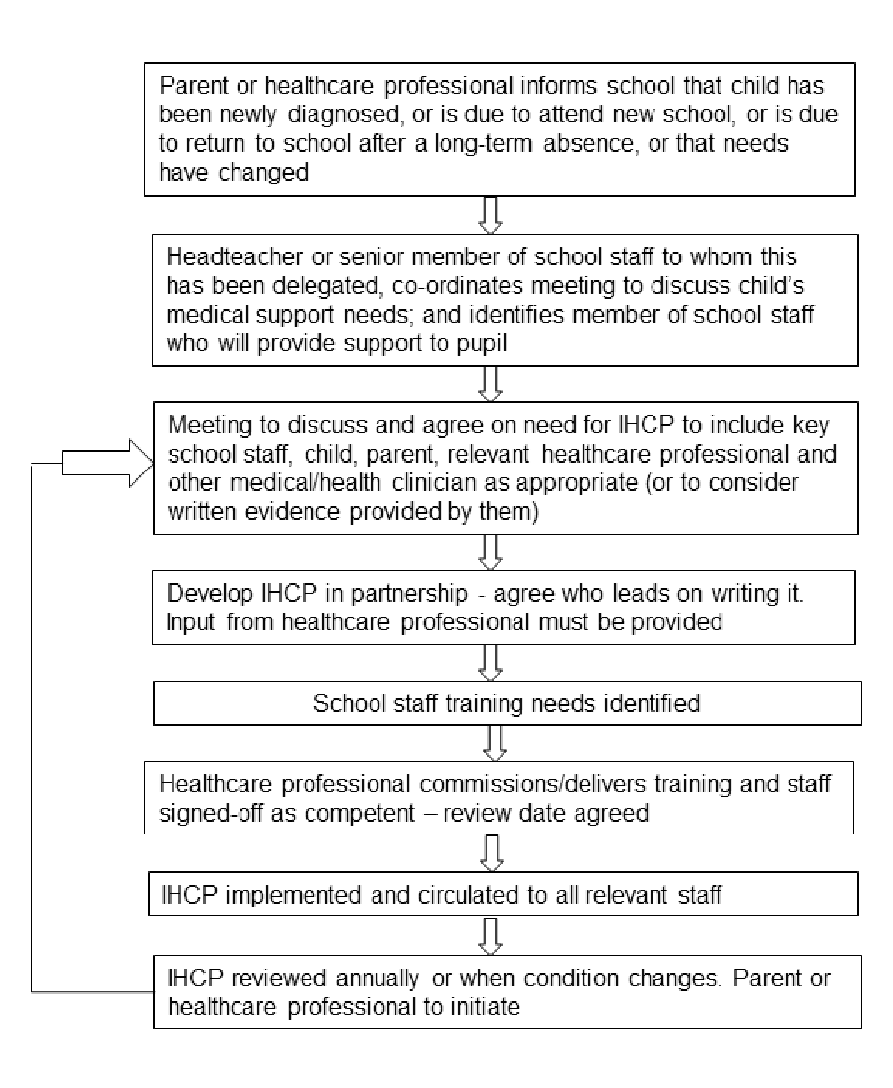

Annex B
INDIVIDUAL HEALTHCARE PLAN FOR A PUPIL WITH MEDICAL NEEDS

NAME DATE OF BIRTH

NHS NUMBER UNIT NUMBER

CONDITION/S

ALLERGIES

CLASS/FORM DATE:

NAME OF SCHOOL: REVIEW DATE:

CONTACT INFORMATION

Family Contact 1, Name, Phone Numbers, Relationship

Family Contact 2, Name, Phone Numbers, Relationship

IC/Hospital Contact, Name, Phone Number

General Practitioner, Name, Phone Number

Describe condition and give details of pupil’s individual symptoms:

Daily care requirements: (e.g. before sport/at lunchtime)

Describe what constitutes an emergency for the pupil, and the action to take if this occurs

Follow-up care

Who is responsible in an emergency: (state if different on / off-site activities)
Offsite Group leader

Form copied to
Headteacher
Class teacher
Consultant Paediatrician etc

Whilst every effort will be taken to ensure this individual healthcare plan is up to date, it remains the parents / carers responsibility to inform school of any changes.

Signed Signed Signed
Health Professional Parent Headteacher

Annex C
Further advice and resources
The Anaphylaxis Campaign
1 Alexandra Road
Farnborough
Hampshire GU14 6BU
Phone 01252 546100 (head office) or 01252 542029 (helpline)
Fax 01252 377140
info@anaphylaxis.org.uk
www.anaphylaxis.org.uk

Asthma UK
18 Mansell Street
London E1 8AA
Phone 020 7786 4900
Fax 020 7256 6075
info@asthma.org.uk
www.asthma.org.uk

Diabetes UK
Macleod House
10 Parkway
London NW1 7AA
Phone 0345 123 2399
Fax 020 7424 1001
info@diabetes.org.uk
www.diabetes.org.uk

Epilepsy Action
New Anstey House
Gate Way Drive
Yeadon
Leeds LS19 7XY
Phone 0113 210 8800 (head office) or 0808 800 5050 (helpline)
Fax 0113 391 0300
epilepsy@epilepsy.org.uk
www.epilepsy.org.uk
Department for Education
Piccadilly Gate
Store Street
Manchester M1 2WD
Phone 0370 000 2288
Typetalk 18001 0370 000 2288
Fax 0161 600 1332
Contact form: www.education.gov.uk/contactus/dfe
www.education.gov.uk

Council for Disabled Children
National Children’s Bureau
8 Wakley Street
London EC1V 7QE
Phone 020 7843 1900
Fax 020 7843 6313
cdc@ncb.org.uk
www.councilfordisabledchildren.org.uk

National Children’s Bureau
National Children’s Bureau
8 Wakley Street
London EC1V 7QE
Phone 020 7843 6000
Fax 020 7278 9512
enquiries@ncb.org.uk
www.ncb.org.uk

Complex and Medical Needs Education Team (CAMNET)
North Lincolnshire Council
Learning Development Centre
Enderby Road
Scunthorpe DN17 2JL
Phone 01724 297149 or 01724 297945
There is a duty to meet the education needs of children with medical conditions. The Complex and Medical Needs Education Team (CAMNET) can support with this by providing home tuition, tuition in hospital and small group teaching for children with medical or mental health conditions. CAMNET can also help children with chronic conditions who are frequently absent from school by providing occasional tuition when required. The team is available to give advice and help to schools about children with medical needs. Contact details for discussion about individual cases / referral - as above.

